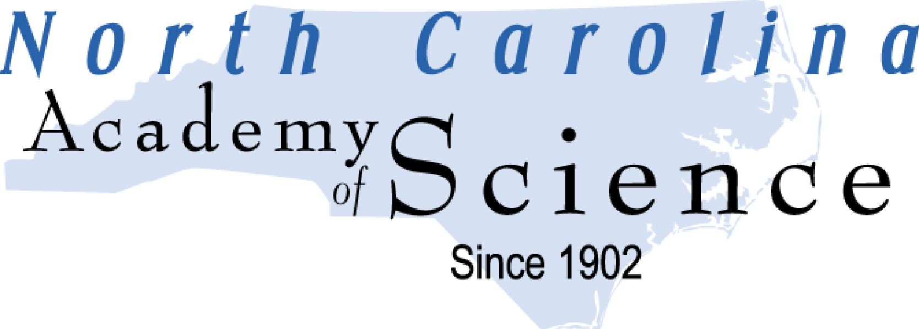

CALL FOR PROPOSALS

ROBERT R. BRYDEN GRADUATE RESEARCH AWARD

1. One $1,000 grant is in the NCAS 2023-24 budget for research equipment and/or expenses related to attending scientific conferences. Past recipients are not eligible.

2. Both the applicant and the research advisor must be at a college or university in North Carolina and members of the NCAS in good standing (membership forms may be obtained from the address listed below or at web site http://www.ncacadsci.org). Please note that this grant program is funded through dues paid by NCAS members. In order to continue this and other valuable NCAS programs, research advisors are encouraged to request their institutions to contribute through an institutional membership.

3. Applications for the grant must include one copy of the following:

• NCAS proposal cover sheet form with one page budget summary. Itemize as specifically as possible.

• Extended abstract of research no longer than 2 pages with three sections.

- Introduction: Background, significance and clear statement of purpose.
- Results: Brief summary of experimental results to date.
- Planned Research: Brief description of work planned over the next year.

4. Send applications electronically to:

Dr. Zhenquan Jia
z_jia@uncg.edu

and

Dr. Mark McCallum
mark.mccallum@pfeiffer.edu

5. Deadline for applications is Feb. 26, 2024.

6. Award will be announced at the NCAS annual business meeting (WSU).

7. Award recipient is strongly encouraged to present his/her work at the NCAS 2024 annual meeting
ROBERT R. BRYDEN GRADUATE RESEARCH AWARD

PROPOSAL COVER SHEET

Title:_____________________________________________________________________________

Field of Research:__________________________________________________________________

Mentor Name:_____________________________________________________________________

Student Name:_____________________________________________________________________

Institution:_________________________________________________________________________

Mailing Address:____________________________________________________________________

E-mail:____________________________________________________________________________

E-mail:____________________________________________________________________________

Phone:_____________________________________________________________________________

Phone:_____________________________________________________________________________

Amount of Grant Requested and Intended Use of Funds (list conference and/or equipment)

Student Certification

I certify that I am a graduate student at the above mentioned institution and that I will be enrolled in the graduate program during the 2023-2024 academic year. I understand that to receive a grant I must (a) be a member of the NCAS and (b) submit a one page research summary report with copies of travel receipts or equipment invoices within one year after the funds are received.

Signature:_____________________________________Date:_________________________________

Faculty Certification

I certify that I am a NCAS member in good standing, the above student is a member of my laboratory and that I approve the intended use of funds as mentioned above.

Signature:___________________________ Date: __________________________________________
NCAS Bryden Grants Research project Rubric
Name: ________________________________ Date: _______________ Score: _______
Category | Excellent  4 points | Good  3 points | Fair  2 points | Poor  I point | No Evidence  0 point | score
Cover page including title | Title  Your Name,  Neatly finished-no  errors | Title  Your Name,  Neatly finished-almost no  errors | Something is missing | Incomplete and/or wrong | Absent
Introduction  (double score) | The introduction is engaging,  states the main topic and  previews the structure of the  project. | The introduction states the  main topic and previews the  structure of the paper. | The introduction states the  main topic but does not  adequately preview the  structure of the project. | There is no clear introduction  or main topic and the structure  of the project is missing. | Absent,  no  evidence
Project statement  (double score) | Clearly and concisely states  the project’s purpose in a single  sentence, which is engaging,  and thought provoking. | Clearly states the project’s  purpose in a single sentence. | States the project’s purpose in a  single sentence. | Incomplete and/or unfocused. | Absent,  no  evidence
Organization-  Structural  Development of  the Idea  (double score) | Writer demonstrates logical  and subtle sequencing of ideas  through well-developed  paragraphs; transitions are  used to enhance organization. | Paragraph development  present but not perfected. | Logical organization;  organization of ideas not fully  developed. | No evidence of structure or  organization. | Not  applicable
Conclusion | The conclusion is engaging and restates the project. | The conclusion restates the  project. | The conclusion does not  adequately restate the project. | Incomplete and/or unfocused | Absent
Mechanics | No errors in punctuation,  capitalization and spelling. | Almost no errors in  punctuation, capitalization  and spelling. | Many errors in punctuation,  capitalization and spelling. | Numerous and distracting  errors in punctuation,  capitalization and spelling. | Not  applicable
Creative activity, including design and procedures  (double score) | The work is creative. The ideas/materials/methods used are effective. | The work is somewhat creative. The ideas/materials/methods used show signs of  Imagination. | The work is not very creative. The approach is trite and the ideas leading to a flat  and predictable performance. | The work is uncreative. | Not  applicable
Budget development | The presented budget is clearly organized. Sufficient details are presented to support the budget. A variety of resources are used. | The presented budget somewhat organized. Some details are presented to support the budget. Some resources are used. | The presented budget unclear.  The information sources are vague. Few details are given to support the budget. | The presented budget is incomplete. No details are presented to support the budget. No sources are used. | Absent
Citation | All cited works, both text and  visual, are done in the correct  format with no errors. | Some cited works, both text  and visual, are done in the  correct format.  Inconsistencies evident. | Few cited works, both text  and visual, are done in the  correct format. | Absent | Not  applicable

